1. **Total Number of flights in certain year**

**SELECT COUNT(Total_flight_completed) as "total fights completedS"**

**FROM flight_activity_fact ff**

**join d_date d**

**on ff.Date_key = d.Date_id**

**where d.year = '&year';**

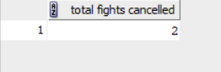

1. **Average duration of delayed flights**

**SELECT round(AVG(ff.Flight_duration),2) as "avg of flights duration"**

**FROM flight_activity_fact ff**

**JOIN flight f**

**on ff.flight_key = f.flight_key**

**WHERE f.Arrival_Time > f.scheduled_arrival_time;**

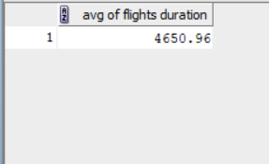

1. **Number of canceled flights in certain Month**

**SELECT COUNT(Total_flight_cancelled) as "total fights cancelled"**

**FROM flight_activity_fact ff**

**join d_date d**

**on ff.date_key = d.date_id**

**where d.Month_num = '&Month';**



1. **Which category has the most Problem_severity ?**

**select Survey_Category, Problem_severity**

**from survey s, customer_care_fact c**

**where s.Survey_Key = c.Survey_Key AND Problem_severity <2;**



1. **avg of problem severity over all categories**

**select s.Survey_Category, avg(c.Problem_severity) as "Avg of problem severity"**

**from survey s, customer_care_fact c**

**where s.survey_key = c.survey_key**

**group by s.Survey_Category;**

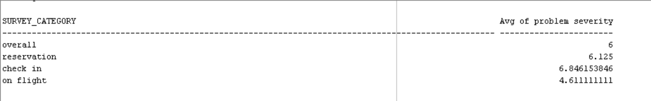

1. **In which time the most surveys come ?**

**select count(Survey_ID) AS NO_OF_ID, Interaction_Date_Type**

**from Survey s, customer_care_fact c, Interaction I**

**where i.interaction_key = c.interaction_key and s.survey_key= c.survey_key**

**and Interaction_Date_Type is not null**

**group by interaction_date_type**

**order by 1 desc;**

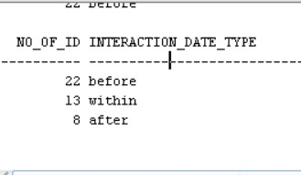

1. **getting the proportion of each frequent flyer category**

**select cat_type, round(count(cat_type) /**

**(select count(p.frequent_flyer_key)**

**from frequent_flyer f, passenger p, reservation_fact r**

**where f.frequent_flyer_key = p.frequent_flyer_key and p.passenger_key = r.passenger_key),2)**

**as "propation of category type"**

**from reservation_fact r, passenger p, frequent_flyer f, frequent_flyer_cat c**

**where p.passenger_key = r.passenger_key and f.frequent_flyer_key = p.frequent_flyer_key and c.frequent_flyer_cat_key=f.frequent_flyer_cat_key**

**group by c.cat_type;**

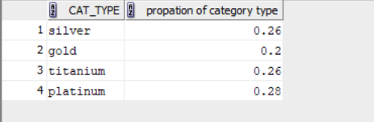

1. **how many frequent flyer change upgrade their flights**

**select class_change_indicator, count(*) as "number of frequent flyers"**

**from reservation_fact r, passenger p, frequent_flyer f**

**where p.passenger_key = r.passenger_key and f.frequent_flyer_key = p.frequent_flyer_key**

**and class_change_indicator is not null**

**group by r.class_change_indicator;**

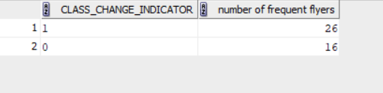

1. **number of accepting promotion for each frequent flyer**

**select p.passenger_id, f.promotion as "number of accpeted promotions"**

**from reservation_fact r, passenger p, frequent_flyer f**

**where p.passenger_key = r.passenger_key and f.frequent_flyer_key = p.frequent_flyer_key**

**and f.promotion is not null**

**order by 1**

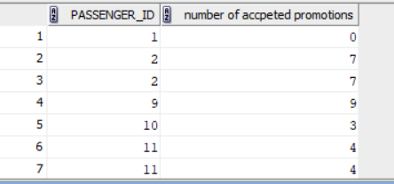

1. **getting the percent of each value in all flights if it is transit or one flight**

**select count_flights_over, round(count(r.count_flights_over)/(select count(r.count_flights_over) from reservation_fact r, passenger p, frequent_flyer f**

**where p.passenger_key = r.passenger_key and f.frequent_flyer_key = p.frequent_flyer_key**

**and r.count_flights_over is not null),2) * 100 || '%'**

**as "proportion of transit flights"**

**from reservation_fact r, passenger p, frequent_flyer f**

**where p.passenger_key = r.passenger_key and f.frequent_flyer_key = p.frequent_flyer_key**

**and r.count_flights_over is not null**

**group by count_flights_over**

**order by 1**

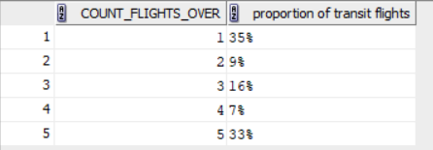

1. **total prices of reservations for each city**

**select city, sum(r.total_price)**

**from reservation_fact r, flight f, airport a, location l**

**where r.flight_key=f.flight_key and a.airport_key=f.airport_key**

**and l.location_key = a.location_key and l.city is not null**

**group by l.city**

**having sum(r.total_price) > 0**

**order by 2 desc;**

